DEPARTMENT OF THE ARMY
HEADQUARTERS, 2ND BATTALION, 325TH AIRBORNE INFANTRY REGIMENT 2ND BRIGADE COMBAT TEAM, 82ND AIRBORNE DIVISION
FORT BRAGG, NORTH CAROLINA 28310

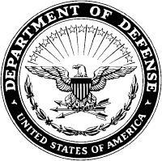

AFVC-BB-CDR 30 July 2026

MEMORANDUM FOR RECORD

SUBJECT: Fort Bragg Family of the Year 2026 Endorsement

- I strongly endorse the nomination of SFC Jamie Howard and his Family for the Fort Bragg Family of Year 2026.

- The Howards are an amazing Army Family. Together they have made their company and the White Falcon Battalion better organizations. Their resilience and compassion for others truly sets them apart.

- The Point of Contact for this memorandum is the undersigned at 910-853-2781 or, terry.l.brown26.mil@mail.mil.

TERRY L. BROWN
LTC, IN
Commanding

